**Database Design with Application Project Proposal**

**Project Title:** Instrument Shop Business (sales, rental, and training)

Project Manager:

Submitted to: Dr. Cheng for IST 634 (Enterprise Databases)

Summer Term 2023 Project

Proposal Date: May 28, 2023.

Contents

Topic Research and Executive Summary 2

Statement of Work 2

Challenges 4

Proposed Solution 4

Project Management Approaches, Schedule, and Milestones 5

Schedule and Milestones 5

Timeline 6

Methodology and Implementation Plan 7

Expected Results: The Deliverables 7

Costs and Benefits 9

Personnel 9

Supporting Facilities 9

# Topic Research and Executive Summary

The project aims to create an Instrument Shop Business that offers sales, rental and training services. The main objective would be to cater for the demands of musical instruments among aspiring music enthusiasts. By enlisting the options to buy, rent and conduct training programs, the business aims to be a panacea for all the needs. To stand out from the general instrument shop, the options of membership, home delivery for the rental instrument and also home training will also be provided.

To achieve the mentioned objective and build a successful business, one has to build partnerships with music instrument manufacturers and distributors. This will build an extensive inventory providing access to a wide range of instruments. Introducing rental services and membership programs will attract customers who want to try out different instruments or need them only for temporary use. The home delivery option will introduce convenience which will attract a large customer base. Training programs will increase long-term customers, as through the business the customers are trained, who full further become buyers and service users.

If the venture is successful certain results are expected. Since there are different attractions for sales, the business anticipates a steady stream of revenue from these different sources. The diversified income model makes sure to generate income flow. Moreover, with the provision of high-quality instruments, reliable rental services and effective training programs with introduced unique home delivery features customer satisfaction and loyalty are expected to build. By showcasing the business in local music events and different music workshops, the business can be ingrained as a hub for the music community.

# Statement of Work

The instrument shop business provides a comprehensive database system to support operations in sales, rental and training services in addition to membership, home delivery and home training programs. The vision of the business is to be a one-stop destination for musicians and music enthusiasts by giving them options for a wide range of instruments, flexible rental options and training programs. The uniqueness of the business with membership features and increased convenience of home services will also add to their vision. The mission would be to implement a database system and build a business in such a way that it will enhance the musical experience and encourage more talent.

The proposed database system will provide all options right from sales transactions to training programs. The user-friendly interface for the employees will be instrumental in streamlining their tasks and improving the efficiency of the operations. The strategy to implement the home services is a key component which differentiates from the competitors. This unique offering will attract more and more customers as people these days are habituated to at-home service.

To elaborate on the goals and objectives of the systems:

1. **Enhance Customer Experience**: The comprehensive business information right from basic customer information to rental history will encourage to give more personalized recommendations and preferences. The inclusion of every feature from training to the availability of various instruments will also foster customer loyalty.
2. **Streamline Operations**: A database system will integrate and automate all the services. With all the services accessible at a single click the workflow will be optimized and the manual effort will be menial. This will reduce human-induced errors and enable the staff to focus on customer interactions increasing overall efficiency and sales of the store.
3. **Expand Business to a larger extent**: In the longer run, this data will be helpful for informed decision-making. Understanding market trends, customer preferences, and sales in different timelines will help to optimize inventory and market for growth.

Every objective induces a different advantage. Increasing sales, streamlining operations, improved customer experience, decision making, growth of the business in future, customer recommendation system, and data analysis are all different advantages that the proposed database system will add to the business.

To briefly describe the scope of the database system, it focuses on the core functionalities required. Every module needed to support sales, rental and training services will be included.

**Customer Details:** A basic CRM module that stores the customer details like customer contact details, previous purchases and subscribed training programs or memberships which fosters user needs and improves customer interactions.

**Inventory Management:** Every store needs to have this module to keep track of the stock of musical instruments for both sale and rent. This will be helpful to upgrade inventory whenever necessary. Maintaining the details of every product right from price to condition will not lead to any inventory mishaps.

**Rental Management:** Booking and tracking of instrument rentals is a key module as this will enable checking availability and rent. A record of the borrowed date and return date will help to give the price calculations and also remind the customers of return dates. This history will also help to keep track of defaulters so that the management will be aware of the next rentals.

**Delivery Management:** Along with the in-store rental pickups and sales, there is an option for home delivery as well. Keeping track of customer address, the status of delivery and other important details will help in analysing data so that the delivery process can be optimized by taking appropriate decisions on the data.

**Training Management:** The details of training programs provided, instructor details, training duration, type of training, attendance history and participant records will help track progress and assessment.

**Sales:** The most important of all the modules is the sales module. The database will support the transactions, invoices, payment methods, order tracking, discounts, coupons etc. This will fasten the receipt generation process faster and the consolidated data also gives an idea of how the business is performing.

## Challenges

Dealing with data comes with added challenges and problems that need to be taken care of. A few problems and challenges are as follows:

**Security:** Hoarding on to sensitive data like customer details and their history will require the need to protect the information. To ensure the security and integrity of the system certain methods like authentication, access control and data encryption methods have to be introduced.

**Migration:** If there is any data which is not in digital database format then the migration of that previous data will require careful planning and execution. Migrating from the current file-based system to the database should ensure that there is no data loss and no security breaches.

**Web Integration:** Integrating the database with a website hosted on the internet which might help to improve the user experience in the long run will also need to establish secure connections over the internet to prevent any malicious hackers.

**Employee Training:** Not everyone has the skill to manage the database, training and workshop programs as to use the system efficiently will require an investment of time and money.

**Maintenance:** With the growing market trends, the system has to be constantly updated and should be in line with the latest features. The maintenance and introduction of flexibility are challenging.

**Budget and Time constraints:** Advanced technology is expensive and the constant need to upgrade and maintain the database will require investment in properly skilled employees. The need to act on time to meet the trend is another thing that needs to be taken care of. Proper budget planning and timeline of every work will help improve the efficiency of the business.

## Proposed Solution

In order to guarantee the security and integrity of the instrument shop business's database, it has been decided to implement a number of preventative measures. We will begin by introducing several effective authentication methods, including biometric authentication, multi-factor authentication, and login and password combinations. As a result, sensitive client data will be protected, and only users who have been granted permission will be able to access the system. Additionally, appropriate privileges will be granted to a variety of individuals in accordance with their roles within the company using access control strategies, particularly role-based access control. This will assist in safeguarding the data's privacy while also preventing unauthorized access. In addition, data encryption techniques will be utilized to safeguard client information throughout its transportation and storage. This will guarantee that anyone who is not permitted to view the data will be unable to comprehend it even if it is compromised. The company that sells instruments may be able to successfully limit the likelihood of potential dangers while also protecting the privacy and confidentiality of customer information by placing a high value on security and implementing authentication, access control, and data encryption.

# Project Management Approaches, Schedule, and Milestones

My prior work experience in corporate evinces my confidence in project management. This would help me to ensure a structured and disciplined approach to the development of the database system for the instrument shop business. Though not exactly the same type of projects, similar projects in past have taught me the importance of effective planning and timely delivery. Choosing a project management framework will help deliver the expected objectives and also makes it easier to achieve the vision and mission. To effectively manage the project, I will adopt a project management framework that has been the backbone for successful projects in the past work experience. That is the Agile framework. The Agile methodology is a framework that is employed by most organizations and is a way to handle the project by breaking it into several phases. There is constant flexibility and incremental value at each stage and this ensures effective project management and mitigates the risk of the project failure. The several stages of the project are assigned to the sprints in this framework and this motivates a disciplined and timely delivery. For the design and development of our project we have followed the non-modified sequential waterfall model. The phases of this sequential project management approach have been mentioned in figure below:

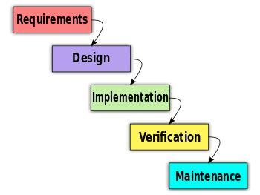

**Figure: Waterfall model**

## Timeline

The project proposal will be completed within the following estimated time.



**Figure 1: Timeline**

|  |  |  |
| --- | --- | --- |
| Stages | Tasks | Personnel |
| Stage 1 | Analysis | Business Analyst |
| Stage 2 | Logical Design | Database Designer |
| Stage 3 | Physical Design | Database Designer |
| Stage 4 | Implementation | Developer |
| Stage 5 | Modification and Maintenance | Quality Assurance Analyst |

**Table 2: Personnel Deployment**

# Methodology and Implementation Plan

The methodology and implementation plan for the instrument Shop Business involves conducting market research, forming alliances with distributors and instrument manufacturers, providing rental services and membership programs, offering training programs with home delivery options, putting effective marketing strategies into practice, ensuring top-notch customer service, assessing performance, and considering expansion opportunities. By providing a variety of instruments, practical rental alternatives, and top-notch training services, the goal is to satisfy the desires of budding music aficionados while fostering customer satisfaction, loyalty, and revenue streams through a diversified income model. During the working on the project, one need to follow the steps such as Analysis, Logical Design, Physical Design, Implementation, Modification and Maintenance.

**Implementation Plan:**

**Phase 1: Requirement Gathering and Analysis**

1. **Understand the Instrument Shop Business:** Thoroughly analyse the administrative procedures associated with managing an instrument shop business. Gather knowledge by consulting with the management and other stakeholders to understand their requirements. Compile data on sales, rentals, training services, instruments, customers, and inventory management.
2. **Selection of Project Management Approach:** Conduct a literature analysis to explore existing approaches for efficient project management during the software development life cycle. Select an approach based on the specific requirements and characteristics of the project.

**Phase 2: Database Design**

1. **Define Database Architecture:** Determine the overall structure and components of the database system for managing instrument shop operations. Consider entities like Instrument, Customer, Sale, Rental, Training, and Inventory.
2. **Establish Data Relationships:** Identify the relationships between different entities to establish proper data connections. Define unique attributes for each entity while ensuring data integrity and consistency.

**Phase 3: Database Implementation**

1. **Create Database Tables:** We will implement the database design by creating tables for each entity. Appropriate data types, primary keys, and foreign keys will be set up to establish relationships between tables.
2. **Load Example Data:** We will populate the database tables with sample data to validate the functionality and performance. Ensuring data is correctly inserted and retrieved.
3. **Indexing and Constraints:** We will set up indexes on frequently queried columns to optimize query processing and implement constraints such as unique, not null, and foreign key constraints to enforce data integrity.

**Phase 4: Functionalities Implementation**

1. **Develop Modules:** We will create modules to manage various components of the instrument shop business, including sales, rentals, training, customer management, inventory management, and financial management. Each module should provide an intuitive user interface and workflow for efficient management.
2. **User Interface Design**: We will Design user-friendly interfaces for each module, considering usability and ease of navigation. Implementing functionalities for adding, modifying, and deleting data, generating reports, and handling transactions.

**Phase 5: Testing and Refinement**

**Conduct Testing:** We will perform rigorous testing of the database and its functionalities and execute unit tests, integration tests, and system-level tests to verify the system's behavior under different scenarios. Identifying and rectifying any defects or issues discovered during testing.

**Software Quality Assurance:** we will ensure that the software product and deliverables adhere to specified quality standards and requirements and conduct comprehensive quality assurance checks to verify the system's reliability, security, and performance.

**Scalability Testing:** We will test the system's scalability to handle high workloads and evaluate its code modularity for future expansion and growth.

**Phase 6: Deployment and Maintenance**

1. **Deploy the System:** Once testing and refinement are complete, we will deploy the instrument shop management system to the production environment. We will provide user manuals and instructions to guide the shop staff in utilizing the system effectively.
2. **Continuous Support and Maintenance:** We will Offer ongoing support and maintenance to address any issues or bugs that arise post-deployment and continuously monitor the system's performance and implement new features and enhancements based on evolving business needs.

# Expected results: The deliverables

The instrument shop business is expected to receive the following deliverables as part of the proposed system:

**Database Tables:** It is absolutely necessary to create a structured and normalized database with tables that precisely reflect the project's scope and meet the needs for business data. Consistency, integrity, and effective data manipulation will all be maintained by each table.

**Queries:** To work with the obtaining and assessment of information, an exhaustive arrangement of inquiries will be formed. Users can use these queries to search, filter, and retrieve specific pieces of information, among other data manipulation tasks. In order to make it easier to make decisions based on accurate information, they will provide useful data and results.

**Reports:** Database data will be used to create reports that are specific to the instrument company, such as financial reports, inventory data, and sales performance reports. The reports will be planned with an emphasis on working with cognizance and assessment, in this way empowering the association to direct and evaluate its exercises really.

**User Training:** A training initiative will be implemented in order to provide every employee with the necessary knowledge and abilities regarding database management. The goal of this preparing is to empower the staff to capably use the information base apparatus and make significant commitments towards its successful administration. The course will cover a wide range of topics, from identifying problems and finding solutions to writing comprehensive reports.

**Data Conversion:** The meticulous organization and transfer of data from the previous file system to the upgraded database system is the process of data conversion. By ensuring that no data is lost during the transition and that all relevant data are accurately transferred to the new system, this method preserves data continuity and integrity.

**Application Design:** To successfully deal with the proposed highlights, an easy to use and instinctive application will be created. It is anticipated that this program will improve data input efficiency and corporate procedures, leading to an overall increase in productivity. It is anticipated that the proposed solution will act as a solid foundation, bringing together various aspects of the instrument shop industry and facilitating seamless operation.

**Maintenance and Support:** A robust database system, effective data processing capabilities, insightful reports, skilled personnel, and a streamlined application will be provided to the company that specializes in musical instruments to help it perform better and achieve the intended outcomes and deliverables.

**Membership System:** A membership platform that would allow potential customers to sign up and become members is planned as part of the planned effort. The proposed system is designed to manage membership data, rights, and subscription information. It is anticipated that this strategy will be implemented to provide specialized services and build client loyalty.

**Rental Management System:** The proposed system aims to provide a comprehensive rental management solution that makes renting instruments and managing rental agreements simpler for customers. The system's goals are to speed up rental transactions, evaluate pricing and availability, and keep track of rental inventory.

**Integration with Website:** The platform's home delivery system will enable customers to request the delivery of purchased or rented instruments to their residence. The expansion of this help is expected to grow client socioeconomics and advance client comfort.

**Training Program Management:** A method for managing training programs is presented to simplify management of the instrument store's training programs. The booking, enlistment, and observing of the preparation projects will be taken care of by this framework. It is anticipated that the implementation of this system will ensure a seamless and continuous client experience and improve the efficiency with which training sessions are managed. [1]

## Costs and Benefits

There are many benefits this implementation offers, to quantify and describe each benefit:

1. **Enhanced Data Management System**
   * Faster data retrieval: 90% reduction in wait time of the customer at shop
   * Reduction in data redundancy: 100% decrease in duplicate data entries.
   * Improved data accuracy: 100% reduction in data errors and inconsistencies.
2. **Enhanced Customer experience**
   * Increased customer interaction by 80%
   * Service time is improved by 80%
   * Customer loyalty is improved by 100%
3. **Budget and Cost benefits**
   * Efficient inventory management reduces inventory mishaps by 90%
   * Improved resource utilization by 100%
4. **Improved Operations**
   * Faster access to information, reduced manual work and manual error

# 

# Personnel

**1: Project Manager:**

* Skills: MS ACCESS DB, C#, Visual studio, and Microsoft Visio.

# Supporting facilities

**Database Management System (DBMS):** SQL Server or MySQL - These DBMS choices give powerful information the executive’s capacities and are broadly utilized for dealing with enormous scope data sets.

**Integrated Development Environment (IDE):** Visual Studio - an exhaustive IDE upholds application advancement utilizing different programming dialects like C#.

**Programming Language:** C# - C# is a well-known programming language for creating Windows-based applications and is viable with the .NET system.

**Web Development Framework:** ASP.NET - ASP.NET can be used to foster the electronic point of interaction for the theater information base administration framework.

**Querying and Data Manipulation:** Organized Inquiry Language (SQL) - SQL will be utilized for questioning, recovering, and controlling information inside the data set. SQL articulations can be executed straightforwardly or through programming language coordination.

**User Interface (UI) Design:** Adobe XD or Sketch - These apparatuses can be used for planning the UI (UI) of the information base administration framework, making visual designs, and prototyping client cooperation.

**Version Control:** Git - Git is a generally utilized rendition control framework that considers effective cooperation, code the executives, and following of changes made during the improvement interaction.

**Project Management:** Jira or Trello - These undertaking the executive’s apparatuses can help with sorting out errands, following advancement, and working with viable correspondence inside the improvement group.

**Instrument Shop Business**

**Reporter:** Student’s Name.

**Progressive Description & Milestones (with Date information):**

**Analysis**

* **Research Details**

**Identify the Business Models**

The instrument shop business employs a variety of business models to meet the diverse requirements of its customers. First and foremost, it sells a wide range of musical instruments through a retail sales strategy. By purchasing instruments from wholesalers and manufacturers, the store can sell them directly to customers and profit from the markup.

In addition to regular retail sales, the store offers rental services. Customers who only require instruments for a short period of time can rent them rather than purchase them thanks to this. By offering rental services, the company can meet the needs of customers who might not require an instrument for a long time or who would like to try out different instruments before making a purchase. The shop only has instruments available for rent, and rental fees provide a steady income stream.[3]

To better meet customer needs, the instrument shop offers training sessions. These drives are pointed towards sprouting artists and music darlings who want to create or work on their melodic capacities. When the company offers classes, workshops, and educational programs, training fees are how it makes money. Training programs not only attract new customers but also establish long-term partnerships because trained individuals may become devoted customers who buy instruments or additional services.

The instrument shop also uses a membership model to give members access to special privileges and reward repeat customers. Discounts on purchases, first access to rental instruments, exclusive events, and customized services are all available to members of a membership club. The company's revenue grows as a result of membership fees, as does a sense of community and customer loyalty.

The shop also uses a home delivery strategy to make it easier for customers to buy from it. Things that customers have purchased or leased can be ordered to be delivered to their homes. Because of this function, customers no longer need to physically enter the store, which also provides a seamless experience. The store might charge a delivery fee or include it in the price of the rental or purchase to make money.

The instrument shop broadens its income streams and takes special care of the singular requests of clients by carrying out these different plans of action. The store becomes a one-stop shop for convenient services, instrument rentals, training programs, and sales thanks to this all-encompassing strategy, which also increases customer happiness and loyalty.

**Business Investigation**

A few crucial characteristics have been identified in order to comprehend the business operations and functionality of an instrument store. In instrument shops, the following standout characteristics are frequently found:

* + **The instrument store's inventory**: It includes a variety of musical instruments, requires efficient inventory management. This involves acquiring instruments from makers and merchants, monitoring stock levels, arranging the stock, and ensuring that they are accessible for buy or rental.
  + **Rentals and sales operations:** The instrument shop sells and rents instruments. Deals tasks include showing and offering instruments to expected purchasers. Users can test out a variety of instruments or meet urgent needs by using rental services that provide instruments on a temporary basis.
  + **Management of Customer Relationships:** Good relationships with customers are essential to the success of an instrument business. This entails providing outstanding customer service, assisting customers in selecting the appropriate tools, responding to their inquiries, and ensuring the contentment of customers.
  + **Instrument Upkeep and Fix:** Instruments require regular upkeep as well as occasional repairs. The instrument shop may provide customers with simple repairs, cleaning, and maintenance services like tuning. As a result, customers get a better overall experience and their instruments stay in good condition.
  + **Preparing and training:** To meet the requirements of fans and aspiring musicians, the instrument shop might provide educational and training opportunities. These programs, which can take the form of one-on-one lessons, seminars, or groups, allow customers to improve their skills or learn to play an instrument.
  + **Online Presence and E-Commerce:** An instrument store may have an online presence or an e-commerce platform in order to expand its customer base in light of the growing trend toward online shopping. Customers can now research products, browse instruments, and make informed purchases online.
  + **Collaborations with producers and suppliers:** The establishment of alliances with instrument manufacturers and suppliers is essential to the success of an instrument store. This ensures constant access to high-quality tools and a wide range of goods.
* **Management of finances:** The instrument shop must adhere to sound financial management, just like any other business. This includes monitoring deals, rental pay, expenses, and productivity. Setting costs, controlling income, and making taught decisions are completely made simpler with viable monetary administration.

**Mission Statement**

The objective of the instrument store is to provide performers and music fans with a warm and inviting atmosphere, outstanding customer service, and a comprehensive selection of premium musical instruments.

**Dialogue to support Mission Statement**

System Developer: "Hello, Mr. Smith, I'm the system developer assigned to work on the Instrument Shop project. Could you please provide some insights to the requirements and objectives of the business?"

Mr. Smith (CEO): "Certainly! Our Instrument Shop is offering a wide range of instruments for sale, rental, and providing training services. Our objective is to create a one-stop-shop."

System Developer: "That sounds exciting! Could you provide more details about the different types of instruments the shop will offer and the target audience?"

Mr. Smith (CEO): "Absolutely! We plan to offer a diverse range of instruments, including guitars, keyboards, drums, brass and woodwind instruments, and more. Our target audience includes both beginners who are just starters and professionals."

System Developer: "Great! In terms of the rental service, how will it work? Will customers have the option to rent instruments for a specific duration?"

Mr. Smith (CEO): "Yes, exactly. We want to provide flexibility to our customers, allowing them to rent instruments for short-term or long-term periods based on their needs. This will be particularly beneficial for beginners who may not want to make a big investment in purchasing an instrument right away."

System Developer: "That's a smart approach. How about the training services? Will you be offering individual lessons or group classes?"

Mr. Smith (CEO): "We plan to offer both individual lessons and group classes."

System Developer: "That sounds like a well-rounded offering. How will the booking and payment process work for customers who want to purchase instruments or avail themselves of training services?"

Mr. Smith (CEO): "We aim to provide a seamless and user-friendly online platform where customers can browse and select their desired instruments or training programs. They will be able to make online bookings and payments securely through the platform. Additionally, we will have a physical store where customers can visit and explore the instruments in person."

System Developer: "Excellent! In terms of customer support, what kind of assistance will be provided to customers who have inquiries or need guidance?"

Mr. Smith (CEO): "Customer support is a crucial aspect of our business. We will have a dedicated customer support team available to assist customers with any inquiries, provide guidance on instrument selection, and address any issues they may encounter. We want to ensure that our customers have a smooth and satisfactory experience with our services."

System Developer: "That's great to hear. It seems like the Instrument Shop project has a clear vision and customer-centric approach. I'm excited to work on this project and bring your ideas to life."

Mr. Smith (CEO): "Thank you! We're thrilled to have you on board. Let's work together to create an exceptional instrument shopping and training experience for our customers."

**Date: 9/23/2022**

**Mission Objectives**

The objectives of our investigation of the instrument shop industry are as follows:

**Meeting Business Management Requirements:** Our primary objective is to develop software that successfully addresses instrument shop management requirements. By understanding the particular requirements of the business, our objective is to provide a system that makes inventory management, sales monitoring, customer management, and other essential business activities simpler.

**Providing a Software Product of Reliability:** We provide users with a reliable and high-quality software that meets all of their performance expectations through rigorous testing and quality assurance procedure. Our objective is to guarantee that the software performs consistently and effectively, minimizing any potential disruptions to business operations.

**Providing a System That Works Perfectly:** Our goal is to provide a product that includes all necessary elements to make operating of instrument shops easier. Financial reporting, sales and rental tracking, customer relationship management, and inventory management are all included in this. We put in a lot of effort to provide a comprehensive solution that meets the business's operational needs and helps processes run smoothly and effectively.

**Establishing an Easy to understand Climate:** We have made it our goal to provide the staff at the instrument store with a software interface that is easy to use and we want to create a user interface that is easy to use and improve the user experience so that staff members can use the program without requiring a lot of technical knowledge or training.

**Information Security:** One important objective of our investigation is to safeguard confidential information. We intend to implement stringent security measures to safeguard client, sales, and other confidential records. Through the integration of encryption, access control, and data backup technologies, our objective is to establish a secure environment while maintaining the trust and privacy of stakeholders.

**Conveyance on Time:** We guarantee that the software solution will be finished by the promised date. Our objective is to employ efficient project planning and development procedures to guarantee that the product is produced, tested, and released on time. We will cautiously screen the task's turn of events and do whatever it may take to stick to the set timetables.

**Dialogue to support Mission Objectives**

System Developer: "Hello, Ms. Thompson, I wanted to discuss our mission objectives. One objective is to meet the business management requirements. Could you share some specific requirements that we should focus on?"

Ms. Thompson (Instrument Shop Owner): "Sure! We need a system that can efficiently manage our inventory, track sales, and handle customer information. It should also help us generate reports and streamline our business operations."

System Developer: "Hi, Mr. Jackson, one of our mission objectives is to provide a reliable software product. What are your expectations in terms of software performance and reliability?"

Mr. Jackson (Instrument Shop Manager): "We need the software to be fast, stable, and capable of handling a large volume of transactions. It should provide real-time updates, ensure data accuracy and reliability."

System Developer: "Hello, Ms. Davis, our objective is to provide a comprehensive system for the instrument shop. What specific functionalities would you like to see in the software?"

Ms. Davis (Instrument Shop Employee): "We need features for inventory management, sales tracking, and customer management."

System Developer: "Hi, Mr. Rodriguez, one of our mission objectives is to create an easy-to-use interface for the instrument shop staff. Any particular design or usability aspects we should consider?"

Mr. Rodriguez (Instrument Shop Staff): "Simplicity is key. The interface should be intuitive and user-friendly, with clear navigation. It would be helpful if the software provides prompts or guidance to assist us in performing tasks."

System Developer: "Hello, Ms. Lee, information security is an important objective. What security concerns or requirements do you have?"

Ms. Lee (Instrument Shop Owner): "We need the software to have strong data encryption to protect customer information. Access control measures should be in place to ensure only authorized personnel can access sensitive data.

System Developer: "Hi, Mr. Wilson, our objective is to deliver the software solution on time. Is there a specific deadline we should work towards?"

Mr. Wilson (Instrument Shop Manager): "We aim to have the software implemented within the next four months. Timely delivery is crucial for us to start benefiting from the system."

# Logical Design

* **The List of Subjects and characteristics**

The proposed framework for the instrument shop business has a rundown of subjects and their going with qualities in its coherent plan. These subjects sub for the different features of the organization and the information that should be overseen and saved. The subjects and their characteristics are as follows:

**Instrument:** This section contains information about the instruments that can be rented or bought at the shop. The instrument's name, type, ID, brand, number, price, and availability could be the attributes. [

**Customer:** The data about clients who visit the store to purchase or lease instruments is the focal point of this subject. A customer id, contact, address, rental history, and might be among the characteristics.

**Sale:** Information on instrument sales transactions is included in this topic. The date of the sale, the item that was sold, the identity of the customer, the payment information and the invoice number could be included in the attributes.

**Rental:** The data relating to instrument rental exchanges is remembered for this subject. The start date, end date, rented item and price could be among the attributes.

**Instrument:** All the data related to the instruments are in this topic. The Training Id, date and duration could be among the attributes.

**Employee:** It covers information about the shop's employees. Some of the features include the employee's name, contact information, position, schedule, income, and performance histories

* **Final Preliminary Field List, Value Field List, Calculate Field List (“Date”)**

|  |  |  |  |  |  |
| --- | --- | --- | --- | --- | --- |
| * **Preliminary Field List** | **Value Field List** | **Preliminary Field List** | **Value Field List** | **Preliminary Field List** | **Value Field List** |
| Instrument Name | String of length (100) | Training Date | String of length (100) | Customer Name | String of length (50) |
| Instrument Type | String of length (100) | Training Duration | Time Variable | Customer Phone No | String of length (50) |
| Instrument Brand | Date Variable | Employee CNIC | Economic, Luxury | Customer Age | Int8 (range: (1, 256)) |
| Instrument Price | Int16 (range: (1, 65,536)) | Employee Address | Int16 (range: (1, 65,536)) | Customer CNIC | String of length (50) |
| Employee Salary | Int16 (range: (1, 65,536)) | Start date | Date Variable | Rental History | Int8 (range: (1, 256)) |
| Employee Name | Int8 (range: (1, 256)) | End Date | Time Variable | Sale Date | String of length (50) |
| Employee CNIC | String of length (50) | Rental Price | String of length (50) | Sale Price | Int8 (range: (1, 256)) |
| Employee Phone No | String of length (50) |  |  |  |  |
| **Calculated Field List** |  | Total Revenue | Int16 (range: (1, 65,536)) |  |  |

* **Implementation Progressive Details**

In the implementation phase of this project, the database of this project has been designed. The graphical representation and description of preliminary Entity Relationship diagram (ERD) of proposed system has been mentioned below:

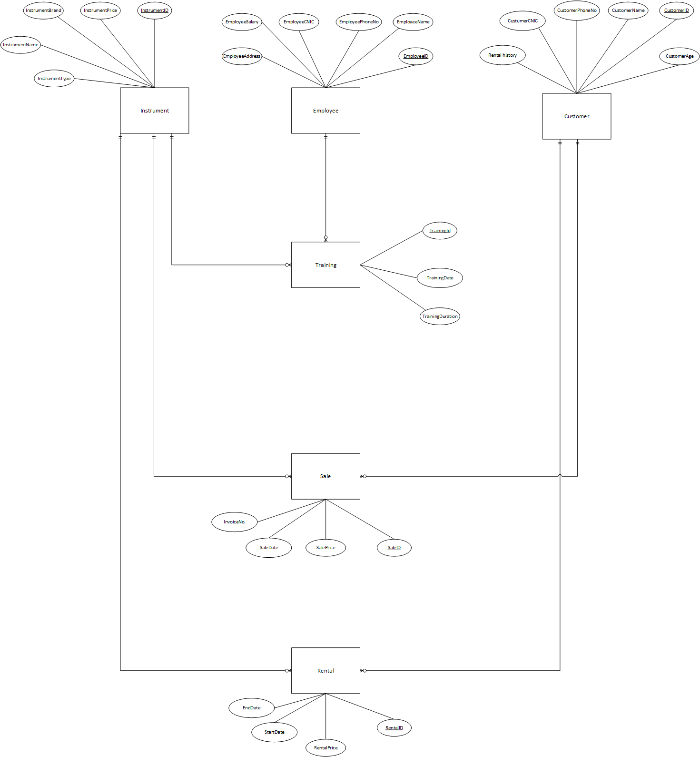

**References**

[1] Cheung, Christy M., and Matthew K. Lee. “Trust in Internet Shopping.” *Journal of Global Information Management*, vol. 9, no. 3, July 2001, pp. 23–35, www.igi-global.com/article/trust-internet-shopping/3558, [https://doi.org/10.4018/jgim.2001070103. Accessed 27 May 2019](https://doi.org/10.4018/jgim.2001070103.%20Accessed%2027%20May%202019).

[2] McIntyre, Charles. “Diminishing Varieties of Active and Creative Retail Experience: The End of the Music Shop?” *Journal of Retailing and Consumer Services*, vol. 16, no. 6, Nov. 2009, pp. 466–476, <https://doi.org/10.1016/j.jretconser.2009.08.001> Accessed 30 Sept. 2019.

[3] Nau, D., et al. “Applications of SHOP and SHOP2.” *IEEE Intelligent Systems*, vol. 20, no. 2, 2005, pp. 34–41, ieeexplore.ieee.org/abstract/document/1413169, <https://doi.org/10.1109/MIS.2005.20> Accessed 3 May 2021